

PARSHVANATH CHARITABLE TRUST'S

1. **P. Shah Institute of Technology**

**Thane, 400615**

**Academic Year: 2022-23**

**Department of Computer Engineering**

# CSL605 SKILL BASED LAB COURSE: CLOUD COMPUTING

**Project Report**

**Project Title: Stock Management System**

Year: T.E. (Sem 6)

Group Members:

Vihang Patil

Kunal Saini

Bhavesh Pawar

**Abstract**

In today's modern world, inventory management is critical for the smooth and efficient operation of various organizations. Most college labs still rely on manual stock recording by staff, which can result in inaccuracies, delays and inefficient management of resources. The proposed stock management system aims to eliminate these problems by automating the inventory tracking process through the use of a web-based application.

The system will be designed to maximize the usage of web applications and ease the staffs’ job. By creating an online database, staff will be able to monitor stock levels, receive alerts when stock needs to be ordered, and track stock movement. Moreover, the proposed system could also remind the person in-charge of the remaining stock as it needed to be ordered or not. This will eliminate the need for manual tracking and provide accurate real-time data.

Furthermore, the system will include automated 2D lab layout creation, which will provide a better User Interface (UI) experience. This feature will help staff locate stock more efficiently and ensure that the inventory is accurately recorded. Additionally, the system will have a simple query mailing system, enabling lab in charge to quickly report problems and keep a record of registered complaints. This will improve communication between staff and the admin, enabling faster resolution of issues.

The proposed system is expected to revolutionize inventory management in college labs, saving time and resources and reducing the risk of errors. By automating the stock management process, the system will allow staff to focus on more critical tasks, improving productivity and efficiency. The system will also provide lab managers with detailed reports, including stock levels, stock movement, and stock utilization, helping them make informed decisions about future stock orders.

Overall, the proposed stock management system is a step towards a more efficient, accurate, and automated inventory management system. It has the potential to change the future usage of inventory systems by streamlining the stock management process for college labs. By embracing technology and automation, the system will enable staff to focus on critical tasks, improve productivity, and ensure that lab inventory is accurately and efficiently managed.**Table of Content**

|  |  |  |
| --- | --- | --- |
| Sr. No | Topic | Pg. No |
| 1. | Introduction | 1 |
| 2. | Problem Definition | 3 |
| 3. | Objective and Scope | 4 |
| 4. | Description | 5 |
| 5. | Software Requirements | 6 |
| 6. | Implementation details with screen-shots (stepwise) | 7 |
| 7. | Deploying Website on AWS | 8 |
| 8. | Learning Outcome | 9 |

**Introduction**

Inventory management is a critical aspect of any business or organization, and it plays a vital role in ensuring smooth operations and maximizing profits. In the education sector, inventory management is equally crucial, and it is especially vital for college labs. College labs require a vast array of equipment, from computers and software to chemicals and scientific instruments, to support students' learning and research activities. Efficient inventory management can save time, reduce costs, and improve productivity in these labs. However, managing and tracking such a diverse range of equipment can be a challenging and time-consuming task, especially if it is done manually.

Traditionally, most college labs still use the manual system to record inventory. This system relies heavily on the staff responsible for maintaining and managing the inventory, making it prone to errors and inefficiencies. In this system, staff manually record the stock and track inventory movement using pen and paper. It lacks transparency, making it difficult for staff to communicate effectively and make informed decisions about inventory levels. This system is not sustainable in today's fast-paced and technology-driven world.

To address these challenges, a web-based stock management system is proposed for college labs. The system aims to automate the inventory tracking process and offer a comprehensive solution to inventory management problems that college labs face today. It will eliminate the need for manual tracking and provide accurate real-time data on inventory levels, stock movement, and stock utilization. The proposed system is designed to make inventory management easy, efficient, and accessible to staff responsible for maintaining and managing lab inventory.

The proposed stock management system offers several benefits to college labs. It is designed to maximize the usage of web applications and ease the staffs’ job. By creating an online database, staff will be able to monitor stock levels, receive alerts when stock needs to be ordered, and track stock movement. The system's automation features will eliminate the need for manual tracking and reduce the risk of errors, delays, and inefficiencies. Additionally, the system could remind the person in-charge of the remaining stock as it needs to be ordered or not.

The system will also include automated 2D lab layout creation, which will provide a better User Interface (UI) experience. This feature will help staff locate stock more efficiently and ensure that the inventory is accurately recorded. Furthermore, the system will have a simple query mailing system, enabling lab in charge to quickly report problems and keep a record of registered complaints. This will improve communication between staff and the admin, enabling faster resolution of issues.

The proposed stock management system has the potential to revolutionize inventory management in college labs, saving time and resources and reducing the risk of errors. By automating the stock management process, the system will allow staff to focus on more critical tasks, improving productivity and efficiency. The system will also provide lab managers with detailed reports, including stock levels, stock movement, and stock utilization, helping them make informed decisions about future stock orders.

In conclusion, the proposed stock management system is an essential step towards a more efficient, accurate, and automated inventory management system. It has the potential to change the future usage of inventory systems by streamlining the stock management process for college labs. By embracing technology and automation, the system will enable staff to focus on critical tasks, improve productivity, and ensure that lab inventory is accurately and efficiently managed. The following sections will provide a detailed description of the proposed system's features and functionality, **Problem Definition**

College labs require a vast array of equipment, from computers and software to chemicals and scientific instruments, to support students' learning and research activities. However, managing and tracking such a diverse range of equipment can be a challenging and time-consuming task, especially if it is done manually. Traditionally, most college labs still use the manual system to record inventory. This system relies heavily on the staff responsible for maintaining and managing the inventory, making it prone to errors and inefficiencies. In this system, staff manually record the stock and track inventory movement using pen and paper. It lacks transparency, making it difficult for staff to communicate effectively and make informed decisions about inventory levels.

Moreover, the current manual inventory system is not sustainable in today's fast-paced and technology-driven world. It is time-consuming, prone to errors, and lacks transparency. The system is unable to provide accurate real-time data on inventory levels, stock movement, and stock utilization, which is essential for efficient inventory management. It can lead to stock shortages, delays in ordering and restocking, and inefficient use of resources.

Therefore, the problem is to develop an efficient and automated inventory management system that can help college labs track and manage inventory more effectively, eliminate the need for manual tracking and provide accurate real-time data on inventory levels, stock movement, and stock utilization. The system should be easy to use, accessible to staff responsible for maintaining and managing lab inventory, and improve communication between staff and the admin. The solution should be sustainable, scalable, and offer a comprehensive solution to inventory management problems that college labs face today.

**Objective**

* To design and develop a user-friendly system that handles the information of items or products, supplier, and lab calculated it to manage the information system.
* To develop an application that deals with the day-to-day needs of any production College.
* To help the lab administrator to communicate with the stock administrator with efficiency.
* To help the user to know which pc is working or which is not.

**Scope**

* Stock Management System (SMS) is targeted at schools and colleges. This system focused on calculating the amount of stock in and out for a college from the stock lab. The scope user for this system is administrators and staff.
* Admin can Login, manage update and view stock in the stock lab, manage reordering process and update or delete. Have full privileges for adding, editing, viewing, and deleting items in stock, supplier details, and lab details from the system.
* Lab Administrator can have privileges to edit or delete lab details, edit pc details, and upload timetable.
* System is web application targeted for schools and colleges to fully utilize the functionality.

**Description**

The proposed project is a web-based stock management system store using html, CSS, and php on AWS for college labs that will automate inventory tracking and provide real-time data on inventory levels, stock movement, and stock utilization.

**Cloud Services:**

The project uses several cloud services provided by Amazon Web Services (AWS), including EC2, RDS, IAM, Elastic IP, and Route 53. Each of these services plays a crucial role in building and deploying the website.

**EC2**:

Amazon Elastic Compute Cloud (EC2) is a web service that provides resizable compute capacity in the cloud. It allows users to quickly and easily provision virtual machines and deploy applications on the AWS cloud.

In the case of the proposed stock management system, EC2 can be used to deploy the application on the cloud. The system can be developed using web-based technologies such as HTML, CSS, and PHP and then deployed on EC2 instances. EC2 allows for easy scaling of the application, as the number of instances can be adjusted based on the workload. EC2 also provides security features, such as firewalls and security groups, to ensure that the application is secure. Additionally, EC2 offers a wide range of instance types to choose from, depending on the requirements of the application.

**Elastic IP**:

Amazon Elastic IP (EIP) is a static, public IPv4 address that can be associated with an instance or a network interface in a particular AWS account.

In the case of the proposed stock management system, Elastic IP can be used to associate a static IP address with the EC2 instance hosting the application. This is important because when an EC2 instance is stopped or terminated, the public IP address assigned to it is released, making it unavailable for use. By using an Elastic IP, the IP address remains associated with the instance even if it is stopped or terminated, allowing for consistent access to the application.

Furthermore, Elastic IP can be used to route traffic to the EC2 instance, even if the instance's public IP address changes. This provides a more reliable way to access the application, as the IP address remains constant even if the instance is replaced or the application is redeployed.

**IAM**:

AWS Identity and Access Management (IAM) is a web service that enables you to manage access to AWS services and resources securely. IAM allows you to create and manage users and groups, and assign permissions to control their access to AWS resources.

In the case of the proposed stock management system, IAM can be used to control access to the application and its underlying resources. This involves creating IAM users, groups, and policies that define their permissions to access specific resources. For example, the application may require different levels of access for lab staff, managers, and administrators, and IAM can be used to define these permissions.

**Route 53**:

Amazon Route 53 is a scalable domain name system (DNS) web service that enables you to manage domain names and route internet traffic to your application.

In the case of the proposed stock management system, Route 53 can be used to register a domain name for the application and route traffic to the application's IP address. This involves creating a DNS record that maps the domain name to the Elastic IP address associated with the EC2 instance hosting the application.

Route 53 also provides advanced features such as traffic routing policies and health checks, which can be used to distribute traffic across multiple instances and ensure high availability and reliability of the application.

**Amazon Relational Database Service (RDS):**

Amazon Relational Database Service (RDS) is a fully-managed database service provided by AWS that can be utilized in a stock management system to store and manage inventory data. RDS allows for easy deployment, scaling, and management of databases in the cloud without the need for extensive infrastructure or administration work.

By using RDS, a stock management system can have a reliable and scalable database backend that can handle large amounts of inventory data with ease. RDS supports a variety of database engines, including MySQL, PostgreSQL, Oracle, and SQL Server, which provides flexibility in choosing the best database engine for the stock management system

**Software Requirements**

**HTML:**

The Hyper Text Markup Language, or HTML is the standard markup language for documents designed to be displayed in a web browser. It can be assisted by technologies such as Cascading Style Sheets (CSS) and scripting languages such as JavaScript.

**CSS:**

Cascading Style Sheets (CSS) is a style sheet language used for describing the presentation document written in a markup language such as HTML.CSS is a cornerstone technology of the World Wide Web, alongside html and JavaScript.

**JavaScript:**

JavaScript is a lightweight, interpreted programming language. It is designed for creating network-centric applications. It is complimentary to and integrated with Java. JavaScript is very easy to implement because it is integrated with HTML. It is open and cross-platform.

**PHP:**

PHP is a widely-used open-source general-purpose scripting language that is especially suited for web development and can be embedded into HTML. Instead of lots of commands to output HTML, PHP pages contain HTML with embedded code that does something. The PHP code is enclosed in special start and end processing instructions <?php ?> that allow you to jump into and out of PHP mode.

**MYSQL:**

MySQL is a fast, easy-to-use RDBMS being used for many small and big businesses. MySQL is a very powerful program in its own right. It handles a large subset of the functionality of the most expensive and powerful database packages. MySQL uses a standard form of the well-known SQL data language. MySQL works on many operating systems and with many languages including PHP, PERL, C, C++, JAVA, etc.

**Implementation Details**

**Setting up the Development Environment**: The first step was to set up the development environment by installing the necessary software tools and packages, such as PHP, MySQL, and Apache.

**Planning and Design:** This phase involves planning the architecture of the application, designing the user interface, and determining the necessary features and functionality required for the system.

**AWS Account Setup:** To deploy the stock management system on AWS, you would need to create an AWS account and set up billing information.

**EC2 Instance Configuration:** In this phase, you would create an EC2 instance and configure the instance by selecting the operating system, instance type, storage, and security settings.

**Installation of Required Software:** Once the EC2 instance is created, the next step would be to install the necessary software required to run the stock management system, such as the **Apache web server, MySQL database, and PHP scripting language.**

**Database Configuration:** The next step would involve configuring the MySQL database by creating a database and user account for the stock management system, and setting up appropriate permissions.

**Application Deployment:** In this phase, you would deploy the stock management system on the EC2 instance by uploading the application files to the web server and configuring the necessary settings.

**Elastic IP Address Configuration:** Once the application is deployed, an Elastic IP address would be associated with the EC2 instance to provide a static IP address for the application.

**Domain Name Configuration:** To provide a user-friendly URL for the application, a domain name would be registered and configured to route traffic to the Elastic IP address of the EC2 instance using Route 53.

**IAM User and Group Configuration:** In this phase, you would create IAM users and groups, and assign appropriate permissions to control access to the stock management system.

**Testing and Deployment:** Once the above steps are completed, the application would be tested to ensure that it is working correctly. Any necessary modifications or updates would be made before the application is deployed for production use.**Deploying the website on AWS**

**Screen Shots:**

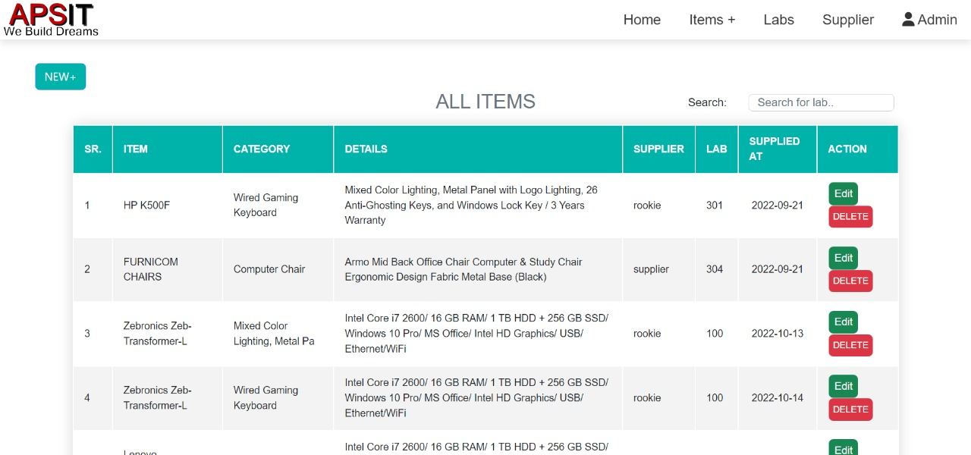****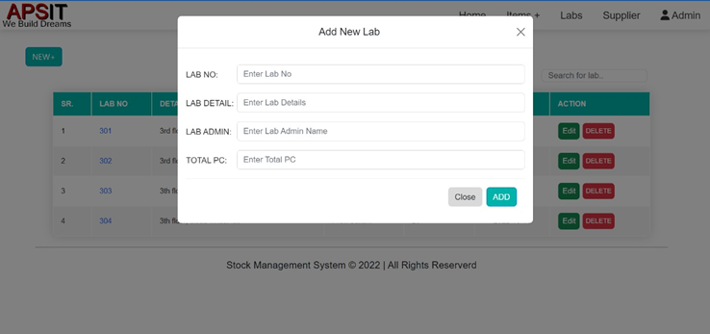

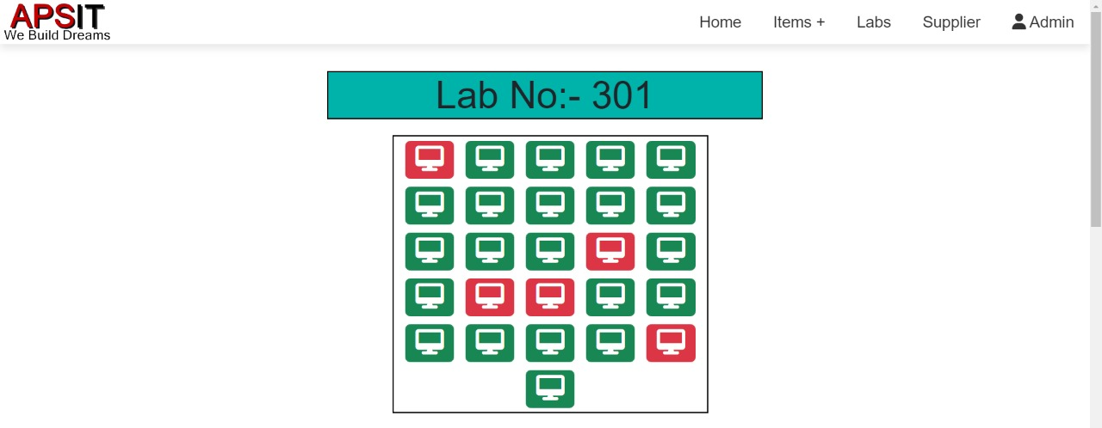**IAM**:

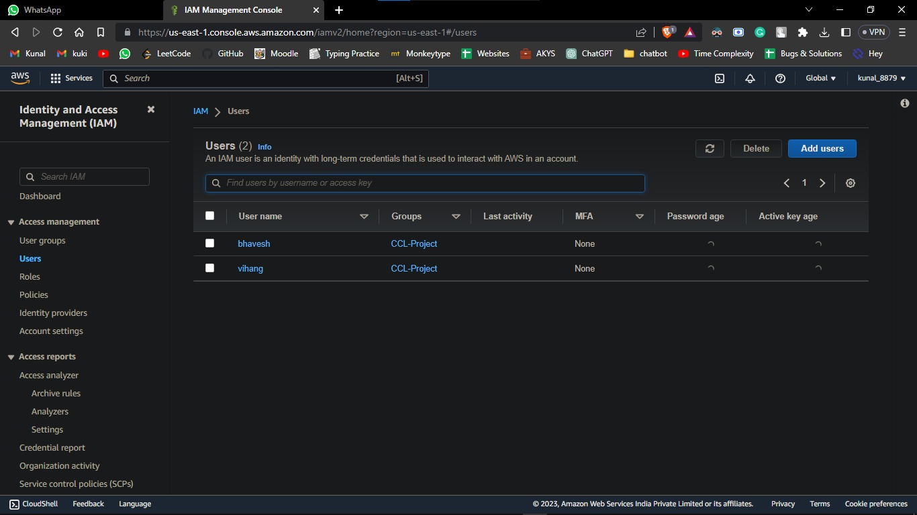

**Route 53:**

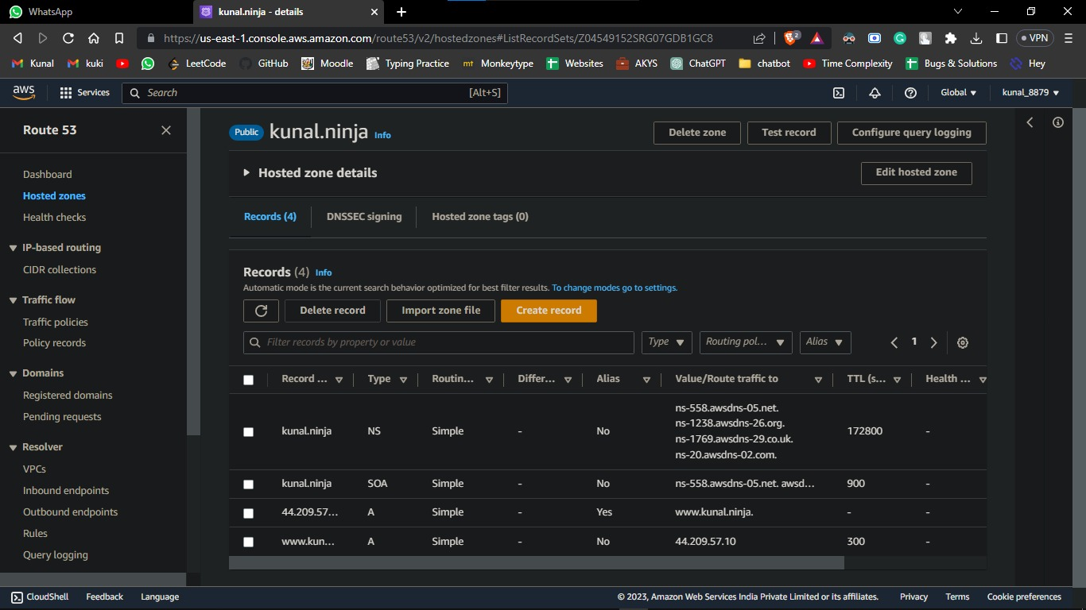

**Elastic IP:**

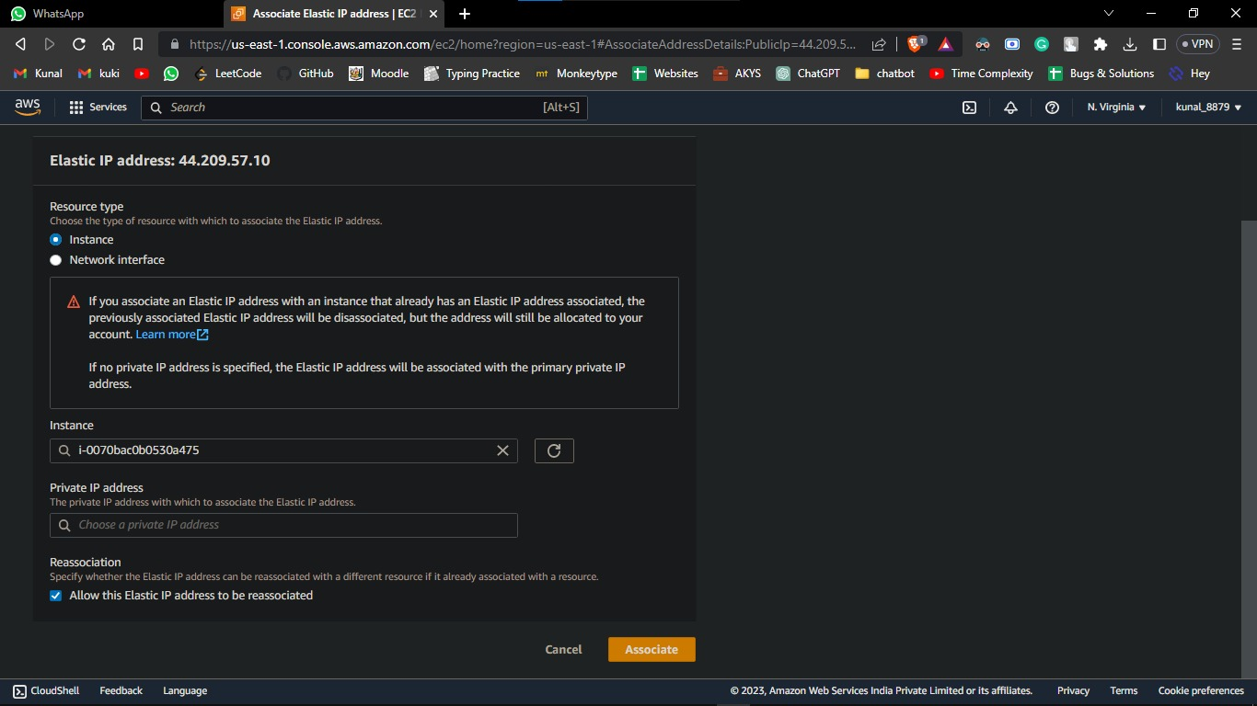

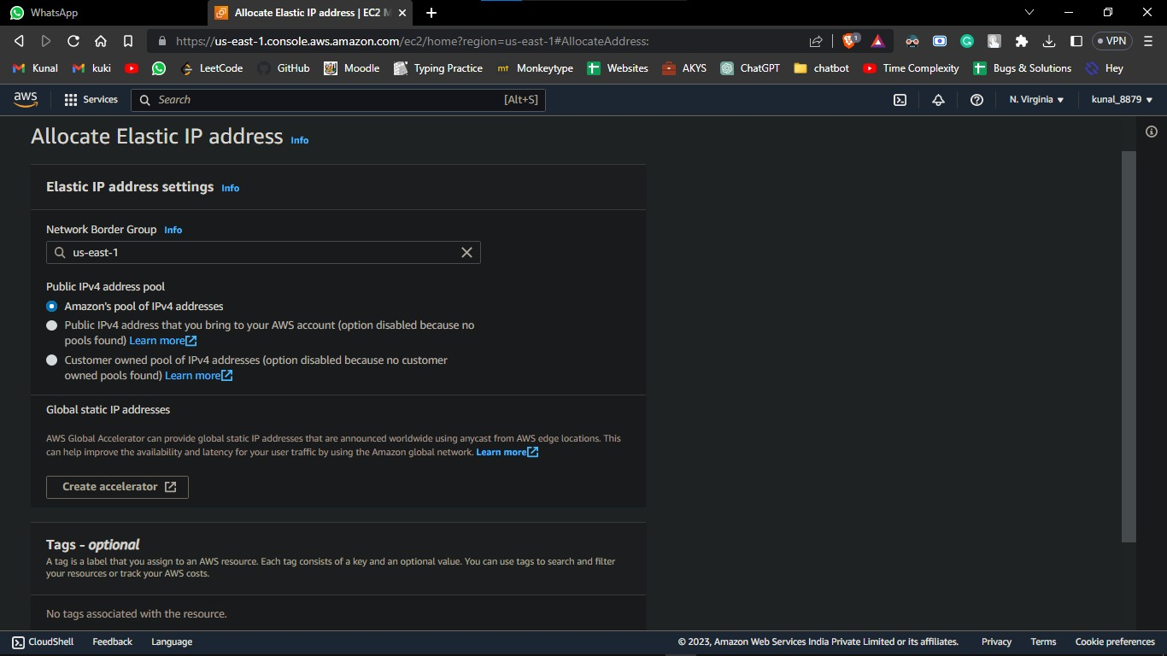

**E2C:**

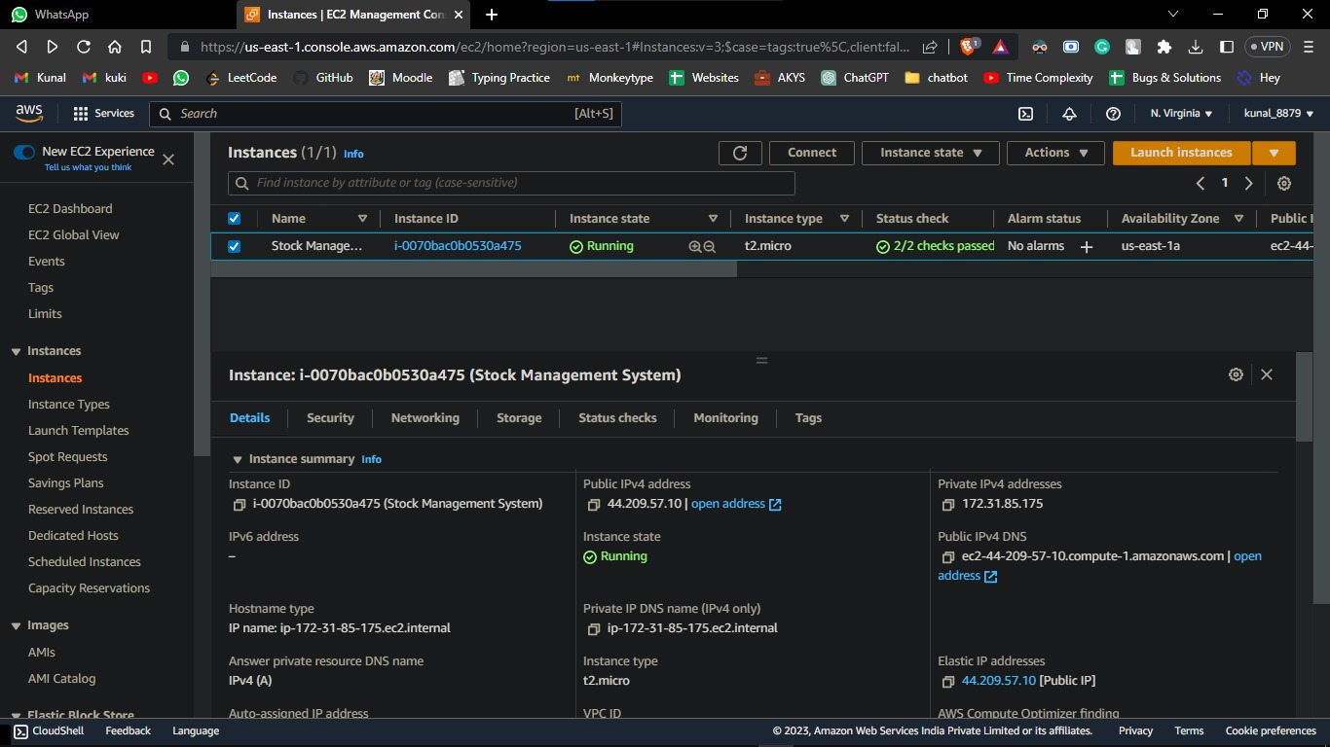

**Learning Outcome**

Learning and implementing AWS cloud can provide several valuable outcomes, including:

**System Administration:** Understanding how to set up and configure an EC2 instance and other AWS services like IAM, Elastic IP, and Route 53 can help you learn system administration skills.

**Database Management:** Working with AWS's managed database services like RDS and DynamoDB can help you learn database management skills like data modeling, backup and recovery, and performance tuning.

**Security:** Learning how to implement security best practices like securing AWS resources using IAM policies, encrypting data using KMS, and using security groups and NACLs to **control network access can help you develop security skills.**

**Cloud Computing:** Deploying a stock management system on AWS can help you learn cloud computing concepts like elasticity, high availability, and fault tolerance.

**Knowledge of Scalability and Reliability:** Working with AWS's scalable services like EC2, RDS, and S3 can help you learn how to design and deploy scalable and reliable systems. Understanding how to use AWS's monitoring and logging services like CloudWatch and CloudTrail can help you troubleshoot and optimize your application's performance.